~ 5 ~
Smallpoxand the First Vaccine
“... they lye on their hard matts, the poxe breaking and mattering, and running one into another, their skin cleaving to the matts they lye on; they turne them, a whole side will flea off at once.”
– William Bradford, 1634
“Fresh vesicles subsequently formed around the vaccination pocks coalescing with them and causing them to spread. They developed also on the face, head, body, and in the mouth, the later prevented the child from suckling, and it died exhausted on the 45th day after vaccination.”
– Case of a healthy child after vaccination, March 13, 1891
“Try re-vaccination – It never will hurt you,
For re-vaccination has this one great virtue:
Should it injure or kill you whenever you receive it,
We all stand prepared to refuse to believe it.”
– From a circular signed “The Doctors”, 1876

Of all the devastating infectious diseases of the past, smallpox stands out as a particularly dreadful killer. Its infamous reputation is in part because it would cover its victims with oozing sores that disfigured and killed many,and in partbecause it was a disease that people tried to use various medical interventions to help prevent.
The first attempt in the Western World in controlling smallpox began with Lady Mary Wortley Montagu in 1717. She had returned from the Ottoman Empire with knowledge of a practice of inoculation against smallpox which was a procedure known as variolation. The procedure entailed taking a small amount of material and scratching the skin of the person. If all went well the person would suffer through a mild attack of smallpox and then would be immune to the disease for life. Inoculation was simply giving smallpox to a person in a time and setting of their choosing. The idea behind inoculation was that in a controlled setting a person would do better against smallpox than contracting it at some possibly less desirable time and place in the future.
“…they generally use a small scratch, or scarification in one arm, and lodge therein a small bit of variolated thread. This is no proportion or dose of variolous matter requisite for inoculation; Pylarini writes, that by pricking the skin with needles dipt in variolous matter or pus, people have been inoculated…”
The problem with variolation is that the treatment could in fact result in the person dying of smallpox. The other major problem was that procedure itself could spread smallpox.
“The ensuing and protecting attack of smallpox was by no means always a mild one; it has been reckoned that two or three persons died out of every hundred inoculated. Further, many people rightly suspected that inoculation, even though it might protect the individual by a mild attack, spread the disease more widely by multiplying the foci of infection. For these reasons inoculation fell into general disrepute in Europe after 1728.”
In 1743, James Kirkpatrick arrived in London from Charleston South Carolina writing of an account of the 1738 epidemic stressing that inoculation has been outstandingly successful. Because of his enthusiasm, inoculation regained favor throughout Europe in the latter half of the eighteenth century.
“In London, after the revival of Kirkpatrick’s influences in 1743, inoculation became a lucrative branch of surgical practice… almost exclusively among the well-to-do. The operation was by no means so simple as it looked. It required the combined wits of a physician, surgeon, and an apothecary; while the preparation of the patient to receive the matter was an affair of weeks and much physicking and regimen. The inoculation was for a long time the privilege of those who could afford to pay for it.”
Because of the complexity and danger involved, inoculation remained an operation that could only be afforded by the wealthy.
“There is no doubt that in Europe, and especially in Britain, inoculation could be an actual danger to the community because smallpox was more common in the cities, where the density of population made isolation of inoculated cases difficult. For this reason, inoculation was almost entirely confined to the wealthier classes who could be isolated in the home or in a special hospital.”
During a 1752 epidemic of smallpox in Boston, figures showed that more people died when exposed to natural smallpox than they did when they contracted smallpox through inoculation.This showed that inoculation did frequently help the individual. Interestingly, blacks died more often both of naturally contracted smallpox and of inoculation. Whites were about 7 times more likely to die of natural smallpox than dying of inoculation. In contrast, blacks were about 2 ½ times more likely to die of smallpox than of inoculation.
“The small-pox in cold countries is more fatal to blacks than whites. In Boston small-pox of 1752, there died whites in the natural way about one in eleven, by inoculation one in eighty; blacks in the natural way one in eight, by inoculation one in twenty.”
Despite inoculation being widely used, there were those that suspected the procedure was in fact spreading smallpox. A1764 article details statistical information that the author believed showed the unintended result of inoculation was increasing deaths from smallpox.
“It is said that a certain number who have the small pox by Inoculation a much smaller proportion dies than of the same number that take in naturally, but admit this to be true, it does not follow Inoculation is a practice favourable to life… It is incontestably like the plague a contagious disease, what tends to stop the progress of the infection tends to lessen the danger that attends it; what tends to spread the contagion, tends to increase that danger; the practice of Inoculation manifestly tends to spread the contagion, for a contagious disease is produced by Inoculation where it would not otherwise have been produced; the place where it is thus produced becomes a center of contagion, whence it spreads not less fatally or widely than it would spread from a center where the disease should happen in a natural way; these centers of contagion are manifestly multiplied very greatly by Inoculation…”
The author of the article showed that inoculation began in London in the year 1721. In the 38 years preceding the start of inoculation, the deaths from smallpox to the number born was 90 per 1,000 and to the number of burials, 64 per 1,000. In the 38 years after inoculation began, the deaths from smallpox to the number born increased to 127 per 1,000 and to the number of burials increased to 81 per 1,000. While inoculation was lauded as helpful in decreasing the likelihood of an individual dying from smallpox, the practitioners of inoculation were creating vectors for spreading the disease that they were trying to prevent. This unintended consequence resulted in an increase in deaths from smallpox.
“There was, however, a catch: individuals under inoculation did come down with smallpox, and they were therefore fully capable of infecting others with the disease. Unless practiced under strict quarantine, the operation was as likely to start an epidemic as stop one.”
A farmer named Benjamin Jetsy was aware of the popular belief that cowpox would protect against smallpox. In 1774, he took material from an infected cow and rubbed it into scratches made with darning needles using his wife and two sons as experimental subjects. He was met with a great deal of criticism for making inhuman experiments on his family, although allegedly when Jetsy’s sons were later deliberately exposed to smallpox they did not come down with the disease.
It was rumored among milk maids that infection with cowpox would protect one from smallpox. Believing these stories, in 1796, Edward Jenner performed an experiment on a young 8-year-old boy named James Phipps. He took disease matter from lesions on a dairymaid, Sarah Nelms, and inoculated James Phipps. He would later deliberatelyexpose James Phipps to smallpox. Because the boy apparently did not contract smallpox, itprovided the evidence that Jenner believed was sufficient to claim that the technique he developed would provide lifelong protection against smallpox.
“For two years Jenner continued with his vaccination experiments. He gave cowpox the name of Variolavaccinae, and showed that it was unnecessary to use lymph from infected cattle. ‘Humanized cowpox vaccine’ that is, lymph from cowpox pustules on human skin, is equally effective. Thus Jenner was able to counter the widespread objection to inoculation with an animal disease.”
There was of course no way to know if James Phipps had previously contracted even a mild case of smallpox, which would have given him immunity or even if he had contract a mild sub-clinical case of smallpox when he was purposefully exposed by Jenner. Jenner’s claims were based on an extremely small sample size and the rumor of lifelong protection once a person was exposed to cowpox. Jenner’s conclusions were ultimately based on anecdotal information and extremely suspect scientific methods.
In 1798,Jenner published his paper on his experiments and encouraged the use of his procedure. While Jenner promoted the use of his technique based on the legend that once you had cowpox you were immune to smallpox, there were doctors of the time that believed this was a myth. At a meeting of the Medico-convival Society he was met with challenges to this notion.
“But he [Jenner] no sooner mentioned it than they laughed at it. The cow doctors could have told him of hundreds of cases where small-pox had followed cow-pox…”
In 1799, a number of children were vaccinated by a Mr. Drake with cowpox matter obtained by Edward Jenner. The children were then tested by being inoculated with smallpox to see if the cowpox procedure had been effective. Although Edward Jenner did not report the results of these children, a Dr. Hughes later reported that the children subsequently had developed smallpox showing that the technique had not worked. Jenner had apparently received the report, but decided to ignore these results that were not in support of his theory.
“In three of them, a lad aged seventeen and two of the Colborne children (one four years, the other fifteen months), the cowpox vesicles came to early maturity and were scabbed under the usual time. The lad was inoculated with smallpox on the 20th December, being the eight day from his vaccination, and the two children on the 21st, being again the eight day. They all developed smallpox, both the local pustules and the general eruption with fever.”
Shortly after, in 1799, Dr. Woodville of the Smallpox Inoculation Hospital in London began extensive use of the vaccine. One hundred thousand people were estimated to have been vaccinated in England by 1801. Dr. Woodville had obtained his vaccine virus from a cow belonging to a dairy in Gray’s Inn Lane in London. He vaccinated seven people, and only 5 days later, he proceeded to use the arm-to-arm vaccination for hundreds. However, almost all of these people had also been also been previouslyinoculated with smallpox. Dr. Woodville acknowledged there were also problems associated with this procedure.
“… in several instances, the cowpox has proved a very severe disease. In three or four cases out of 500, the patient has been in considerable danger, and one child actually died.”
The term vaccination began to be used and promoted as a better alternative to inoculation. Unlike inoculation which was exposing the person to smallpox, vaccination, also known as “cowpoxing,” would expose a person to a supposedly less harmful disease to somehow protect the person from smallpox.
While many in the medical profession quickly supported this procedure as a lifelong protection against smallpox, there were no true controlled experiments. There was no test where one group was vaccinated compared to another that was not. In addition, the early vaccinations may have in fact been contaminated with smallpox.
“Dr. Creighton shows reason for believing that the lymph he used was contaminated with small-pox, and that the supposed vaccinations were really inoculations.”
Only four years after Jenner’s discovery, the idea had been embraced by the heads of the medical profession;although reports early on showed there were cases of people who had cowpox or were vaccinated that were still dying of smallpox. Specific cases of cowpox and vaccine failure were reported in the 1809 Medical Observer.
“1. A Child was vaccinated by Mr. Robinson, surgeon and apothecary, at Rotherham, towards the end of the year 1799. A month later it was inoculated with small-pox matter without effect, and a few months subsequently took confluent small-pox and died.
2. A woman-servant to Mr. Gamble, of Bungay, in Suffolk, had cow-pox in the casual way from milking. Seven years afterwards she became nurse to Yarmouth Hospital, where she caught small-pox, and died.
3 and 4. Elizabeth and John Nicholson, three years of age, were vaccinated at Battersea in the summer of 1804. Both contracted small-pox in May, 1805 and died
…
13. The child of Mr. R died of small-pox in October 1805. The patient had been vaccinated, and the parents were assured of its security. The vaccinator’s name was concealed.
14. The child of Mr. Hindsley at Mr. Adam’s office… died of small-pox a year after vaccination.”
These early indications showed that the idea ofexposure to cowpox providing lifelong immunity to smallpox was simply not true. People could and were still dying from smallpox, even though they had been exposed to cowpox or had been vaccinated.
“The Medical Observer for 1810 contains particulars of 535 cases of small-pox after vaccination, 97 fatal cases, 150 cases of vaccine injuries, with the addresses of ten medical men, including two professors of anatomy, who had suffered in their own families from vaccination.”
An 1817 article in The London Medical Repository Monthly Journal and Reviewshowed that a great many people who had undergone vaccination were still suffering from smallpox.
“Variola, above all, continues and spreads a devastating contagion. However painful, yet it is a duty we owe to the public and the profession, to apprize them, that the number of all ranks suffering under Small Pox, who have previously undergone Vaccination by the most skilful practitioners, is at present alarmingly great. This subject is so serious, and so deeply involves the dearest interests of humanity, as well as those of the medical character, that we shall not fail in directing our utmost attention to it.”
During the1817 epidemic of smallpox that raged in thetown of Cupar,north of Edinburgh England, a Dr. Dewar examined 70 cases of which 54 had been vaccinated or referred to, as having gone through the “vaccine disease.”Of the 54, most had a well-marked eruptive fever,except 8 that had previously been inoculated with smallpox and 2 who had not been inoculated. Of the 54 vaccinated, 1 died. However 6 of the 16 that had not been vaccinated died. Most of the vaccinated suffered varying severity of the disease and in 8, the disease was remarkably mild.
“Admitting that all the fifty-four patients had had the true vaccine disease, and that all the cases detailed were instances of genuine small-pox, the conclusion is, that vaccination ‘did not ultimately prove a certain preventive of small-pox; yet it evidently gave, in some instances, a remarkable temporary or occasional protection;’…”
Vaccination afforded a “possible or probable” but not “certain” protection from an attack of small-pox. Vaccination seemed to “secure the constitution from secondary fever” and led Dr. Dewar to conclude that “vaccination ought still to be valued and universally recommended.”Because these were not controlled studies, it was impossible to determine the true effect of the vaccine. Those that had appeared to have some protection may have had been previously inoculated against smallpox or even had smallpox. This was not a study that truly proved that vaccination should be “universally recommended” as Dr. Dewar had concluded.
There were those that saw that vaccination was not fully protective again smallpox. They argued that even though inoculation with smallpox was more risky, it provided for better immunity. Vaccination might provide a temporary protection, but would only delay catching the disease until later.
“The most unfavorable conclusion therefore that can be admitted is, there may be the same risk of deaths from small-pox after vaccination, as of deaths in the early stage of the inoculated small-pox. Thus the risk is not only deferred to a later period, but is ultimately far inferior to what it was under the use of the best inoculation previously to the discovery of the cow-pox, and is in fact reduced almost to nothing.”
Other observations showed that smallpox could still infect those who previously had smallpox, and those that were vaccinated could also be infected.
“… during the years 1820, 1, and, 2 there was a great hubbub about the small-pox. It broke out with the great epidemic to the north… It pressed close home to Dr. Jenner himself… It attacked many who had had small-pox before, and often severely; almost to death; and of those who had been vaccinated, it left some alone, but fell upon great numbers.”
William Cobbett was a farmer, journalist, and English pamphleteer. In 1829, he wrote about the failure of vaccination to protect people from smallpox. Despite being vaccinated even by the inventor and promoter of vaccination, Edward Jenner, hundreds still contracted smallpox and some died. Cobbett considered vaccination to be an unproven and fraudulent medical practice. Cobbett’s reference to 20,000 pounds no doubt refers to the amount the British government had recently advanced to Edward Jenner in 1822 for further smallpox vaccine experimentation.
“In the midst of all this mad work, to which the doctors, after having found it in vain to resist, had yielded, the real small-pox, in its worst form, broke out in the town of Ringwood, in Hampshire, and carried off, I believe, more than a hundred persons, young and old, every one of whom had had the cow-pox ‘so nicely!’ And what was now said? Was the quackery exploded, and the granters of the twenty thousand pounds ashamed of what they had done? Not at all: the failure was imputed to unskillful operators; to the staleness of the matter; to its not being of genuine quality… what do we know now? Why, that in hundreds of instances, persons cow-poxed by JENNER HIMSELF, have taken the real small-pox afterwards, and have either died from the disorder, or narrowly escaped with their lives!”
Edward Jenner believed fact the cowpox disease had originated from a disease of the horse called the ‘grease.’ He believed that genuine cowpox came from this horse-grease and proceeded in vaccinating people from this source. Some practitioners used other animals, such as goats, as sources of vaccine material.
“The lymph which Dr. Jenner then used, and which he had kept in circulation three or four years about Berkeley, had been taken by him, not from the cow, but the horse, and never subsequently passed through the constitution. In fact, the disease is an equine, not a vaccine [cow] pox, as he decisively ascertained before he died, obtained from the vesicles which arise upon the skin of the horse’s legs, in consequence of an erysipelatous affection excited by the matter of grease... I have extracted an account form some country of a goat pox, which so resembled the vaccine, that the doctors inoculated with it, and found it an equal preservative. However, this equine lymph of Dr. Jenner produced a vesicle, which, he declared precisely resembled the natural cow-pox vesicle on the teat of the cow…”
For years “humanized cowpox vaccine” had been used. This meant that material was not taken directly from cows, but from human subjects that had been vaccinated to be used to vaccinateother people. However, by 1829 the vaccine was thoughtto be weaker and there were calls to get fresh vaccine material from cows.
“I do not know if in England you have remarked of the diminution of the antivariolous property of the vaccine, but, in France, we observe it every day. Many children submitted to the vaccine have had the small-pox, even the confluent, and many have been victims of that frightful malady. In vain have some physicians denied the degeneracy of the vaccine. That fluid, evidently, is no more what it was…It has evidently degenerated through the continuity of its employment, and to restore its efficacy, I think it will be necessary to return to its origin, and henceforth, derive it only from the teats of the cow.”
Because vaccination was being done arm to arm, the vaccine fell out of favor with many having “disgust towards it.” Dr.Delagrange determined that it was needed to be taken from the “nipple” of the cow only, and not from the arms of others.
“…very few seek it, in spite all our government has done to propagate it. The vaccine, then, is fallen into general discredit; and it may be said, at least in France, that it is upon the point of being absolutely abandoned, unless steps are soon taken to put an end to the cause of this rejection.”
In an attempt to make new sources of vaccine, cows were infected with horse grease as well as humanized cowpox. However, these attempts failed to create new sources of vaccine.
“…the old vaccination committee had repeatedly attempted to produce vaccinia, by inoculating cows both the matter of the “grease” and with that of human cowpox vesicles, but always unsuccessfully.”
An 1834 article detailed the debate of the origin of vaccine virus.
“Three opinions exist as to the origin of the vaccine virus. 1st. That of Jenner, who supposed that it proceeded from a malady of the horse, called the Grease, which was contagious, and gave to cows that form of complaint denominated cow-pox. 2nd. That of Dr. Robert of Marseilles, who thought that the vaccine virus was nothing less than the small-pox poison communicated to cows, and modified by transition. 3rd. The opinion that this complaint is as natural to cows as rot to sheep, the small-pox, measles, or scarlatina to man… Dr. Fiard expresses, as his opinion, that the cow-pox is a malady peculiar to cows; that it is very rare in England, in these animals; and that, in France, there is no evidence to prove that it has ever been produced.”
An 1837 paper showed that it was thought that vaccination would not fully protect an individual as first believed, but concluded that it would result in a more mild disease.
“But during this unhealthy season the whole of the vaccinated did not escape; many, indeed, were affected with modified small-pox… there were a few of the vaccinated who had the small-pox in the severest form, but those were so few in comparison with those who had it in its mild form… it cannot but be concluded, that although vaccination does not at all times completely protect the human frame from the infection of small-pox, it does so in many instances, and those who systems it does not entirely shield, it so far prepares, that, instead of being afflicted with a long-continued, dangerous, and loathsome disease, they are only affected with a mild disorder…”
In 1836, in Attenborough, Massachusetts, Dr. John C. Martin took fluid from a pock of a man who died from smallpox and inoculated on a cow’s udder. He then took matter from that cow and used it to vaccinate people. One of the vaccinated came down with unexpected symptoms and he was later declared to have smallpox. An epidemic of smallpox ensued causing a panic.
“Then those who had been vaccinated from the same source inquired anxiously what was to be their fate… others soon began to be affected… Excitement and consternation prevailed, sustained by the consecutive occurrence of new cases. Business was suspended; the panic of fear magnified the danger, and no man could see where it would end… Two hospitals were established, to which many of those attacked were removed. Four months elapsed before the last patient was discharged.”
An 1865 experimental inquiry would later conclude that this type of vaccination was simply practicing inoculation. Dr. Charles Creighton noted the incident in his writing on vaccination in the 1894 edition of The Encyclopedia Britannica.
“The result was an epidemic of smallpox, a panic, and the suspension of business. On the face of it this method was simply variolating the cow and inoculating the human subject with that curiously disguised smallpox matter.”
In England in 1840, inoculation of smallpox was made illegal and vaccination become the preferred method in attempting to protect against smallpox. In the 1844 smallpox epidemic, while some who were vaccinated came down with a mild version of the disease, roughly eight percent still died of the disease. While it was now recognized the vaccine would not fully protect someone from dying of smallpox, it was still believed to reduce the death rate. A cicatrix, or plural cicatrices, was the mark(or scar) left on the body indicating that vaccination had been performed.
“The character of the disease was very severe. The deaths amounted to 151, being at the rate of twenty-three and a half per cent. In 1781, when the same number of patients was admitted, the deaths were 257, being at the rate of forty per cent. Of the total admitted, 312 were reported to have been vaccinated, and had congnizable cicatrices [recognizable vaccination marks]; twenty-two professed to have been vaccinated, but no scars were detected; two alleged but on unsatisfactory grounds, that they had been inoculated for small-pox in early life. Among the 312 vaccinated, 100 had the disease in very mild form usually called varioloid; in a certain number no mitigation was observed; twenty-four died, being at the rate of nearly eight percent.”
At this time there were those that argued for the superior protective power of inoculation over vaccination. The vaccinated were still dying at 7%, while those who were inoculated had only a 0.2% death rate.
“Founding his views on the now indisputable fact that small-pox spreads as widely without accompanying inoculation, and on the now equally established fact, that small-pox after vaccination proves fatal at the rate of seven per cent., while inoculated small-pox is fatal only at the rate of one fifth, or one in 500, the author proceeded to argue that it is unwise to prevent variolous inoculations in toto.”
In 1845,Negri of Naples used humanized vaccine virus and then artificially implanted it in cows to create a source of vaccine virus that could then later be harvested from cows. This in turn produced a usable vaccine virus from a “bovine” source. This practice spread to France in 1866, and then to the United States in 1870. The original vaccine lymph was obtained from France and inoculated into a herd of cows on a farm near Boston Massachusetts. This effort was because of the belief that the vaccine virus would be better if obtained from the “nipple of the cow”.
A letter to the editor in 1850 claimed there were more admissions to the London Small-Pox Hospital in 1844 than during the smallpox epidemic of 1781 before vaccination began. The author also notes that one third of the deaths from smallpox were in people which had previously been vaccinated.
“Daily experience now unhappily shows an altered state of things: small pox, in spite of vaccination, is rapidly on the increase… There were more admissions to the London Small-Pox Hospital in 1844 than in the celebrated small-pox epidemic of 1781 before vaccination was introduced. I shall also select the Registrar’s returns of one of the country districts (Bradford) to show how little protection vaccination afforded in the last quarter of that year, 1844: 118 (181?) deaths from small-pox were recorded, 60, or nearly one-third, of which had been vaccinated.”
During the 1800s there were periodic reports made in the newspapers of people who died from smallpox despite being vaccinated properly. There were also reports of people that died after vaccination. Death from a skin condition called erysipelas was a particularly prolonged and painful way to die.
“… a boy from Somers-town, aged 5 years, ‘small-pox confluent, unmodified (9 days).’ He had been vaccinated at the age of 4 months; one cicatrix… the wife of a labourer, from Lambeth, aged 22 years, ‘small-pox confluent, unmodified (8 days).’ Vaccinated in infancy in Suffolk; two good cicatrices… the son of a mariner, aged 10 weeks, and the son of a sugar baker, aged 13 weeks, died of ‘general erysipelas after vaccination, effusion of the brain.’ ”
“A girl, aged 4 months, died from erysipelas after vaccination.”
“8 deaths were tabulated under small-pox, of which two attributed to ‘erysipelas after vaccination,’ and one to ‘effects of vaccination.’ ”
“Two children, both of the age of six months, died from erysipelas after vaccination. In one case the erysipelas commenced a fortnight after the operation.”
Claims were made that deaths from vaccination were often not reported because of an allegiance to the practice of vaccination. If a person had been vaccinated, their death was less likely to be recorded as a death from smallpox. Sometimes a person would be indicated to have died from another condition such as chickenpox or it might be indicated that they had not been vaccinated. How often this happened is difficult to determine, but it must have had some impact on the statistics of the day.
“… deaths from vaccination and re-vaccination are hushed up… Mr. Henry May, writing to the Birmingham Medical Review, January, 1874, on ‘Certificates of Death,’ says ‘As instances of cases which may tell against the medical man himself, I will mention erysipelas from vaccination and puerperal fever. A death from the first cause occurred not long ago in my practice, and although I had not vaccinated the child, yet in my desire to preserve vaccination from reproach I omitted all mention of it from my certificate of death.’ ”
“One child, Elizabeth Sabin, 4 years of age, with six good marks of successful vaccination, caught small-pox and three weeks and three days after being vaccinated, and died. Her case was excluded from the list of the vaccinated in Dr. Bond’s statistics. Statistics cooked in that way could not be accepted as accurate. He remembered a case in Birmingham where a man named William Wood Warner died of malignant small-pox in eight days, and was classified by the doctor of the hospital as unvaccinated. By the merest of chance he found out from the man’s widow and sister that the latter had seen him vaccinated.”
Throughout the 1800’s various laws were put into place and used to ensure people were vaccinated. In England, vaccination was made compulsory in 1853. More strict laws were passed in 1867. In 1855, Massachusetts created a set of comprehensive vaccination laws.
“…in 1855 Massachusetts took the most advanced stand ever taken by any of the states and enacted a law which required parents or guardians to cause the vaccination of all children before they were two years old, and forbade the admission of all children to the public schools of any child who had not been duly vaccinated. The selectmen of towns, mayors and aldermen of cities were to ‘enforce the vaccination of all the inhabitants’ and to require re-vaccination whenever they judged the public health to require it; all employees of manufacturing companies, all inmates of almshouses, reform schools, lunatic asylums, and other places where the poor and the sick are received, or houses of correction, jails, prisons, of all institutions supported wholly or partly by the state were to furnish the means of vaccination to such persons as were unable to pay.”
City of Boston documents during that time show strong support for the idea of compulsory vaccination. An 1856 report by Lemuel Shattuck emphasized the need for vaccination and pushed for the idea of house-to-house vaccination enforced by the authority of the city of Boston.
“Is there an effectual remedy which can be applied for the removal of this great evil? In the judgment of the undersigned there is; and that remedy is compulsory vaccination. The City has already provided that no unvaccinated child shall be admitted into the public schools; and for the class of persons interested it is a most excellent regulation. It has also provided for the gratuitous vaccination of such persons as may apply to the City Physician for that purpose.”
Data from Boston that begins in 1811shows that starting from around 1837 there were periodic smallpox epidemics that culminated in a great 1872 epidemic (G2: Boston Smallpox 1811-1926). After 1855 there were further smallpox epidemics in 1859-60, 1864-65, 1867, and the large epidemic in 1872-73. These repeat smallpox epidemics showed the strict vaccination laws instituted by Massachusetts in 1855 had little if any effect (G3:BostonSmallpox1841-1880).
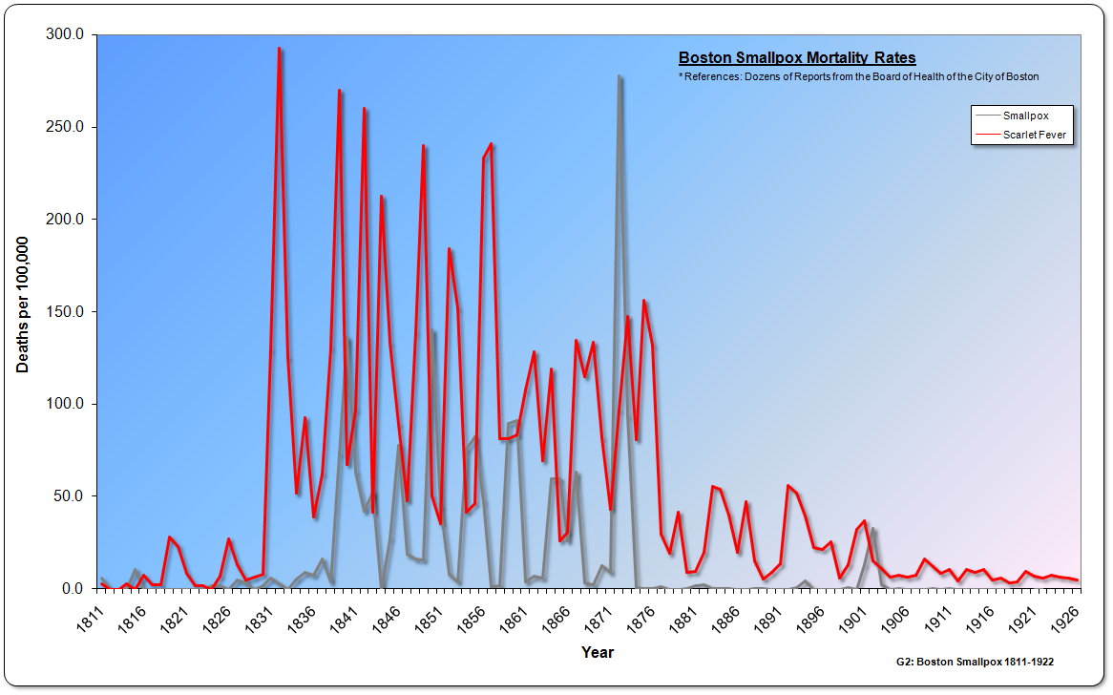

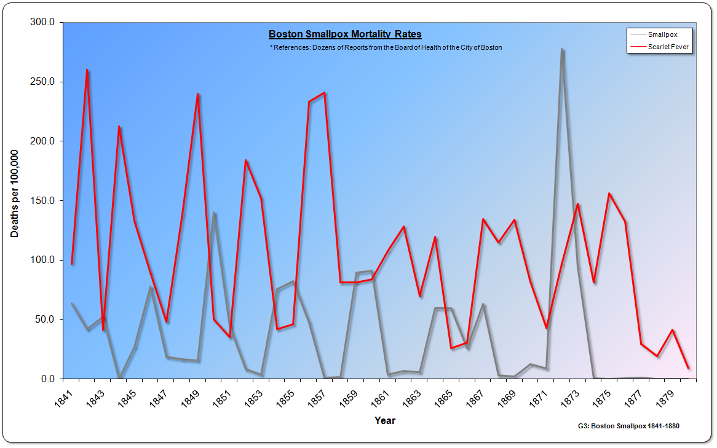

“…small-pox, after having almost wholly disappeared from our community during the thirty or forty years which followed the introduction of vaccination in 1800, gradually regained its foothold in Boston, where it continued to prevail almost uninterruptedly, although with varying intensity, from 1839, when the disease for the first time assumed the form of a distinct epidemic, up to 1873. During this period of thirty-five years the course of small-pox has been marked by a succession of epidemic paroxysms, generally by intervals of several years, during which a varying number of sporadic cases has testified to the more or less constant presence of the disease. The latest epidemic that of 1872-1873, having proved fatal to 1040 persons, was the most severe that has been experienced in Boston since the introduction of vaccination.”
In fact, from 1870 to 1873 a smallpox pandemic hit many of the countries of the Western World. Despite strict vaccination laws in place, there were many deaths.
“… in 1871 ensued a terrible smallpox epidemic which threw both New York and Philadelphia into mourning. It killed over eight hundred people in the former city, more than ever before in its history, while in the latter the deaths nearly reached two thousand.”
In a 1900 article Dr. Harman indicated that over 70% of patients in London Hospitals suffering from smallpox had been vaccinated, and that in 1871 throughout England 122,000 vaccinated people has suffered from smallpox. He also stated that in Germany 1 million people had died from smallpox despite being vaccinated.
“Every recruit that enters the French army is vaccinated. During the Franco-Prussian war there were twenty-three thousand four hundred and sixty-nine cases of small-pox in that army. The London Lancet of July 15, 1871 said: Of nine thousand three hundred and ninety-two small-pox patients in London hospitals, six thousand eight hundred and fifty-four had been vaccinated. Seventeen and one-half per cent of those attack died. In the whole country more than one hundred and twenty-two thousand vaccinated persons have suffered from small-pox… Official returns from Germany show that between 1870 and 1885 one million vaccinated persons died from small-pox”
In an 1898 article Dr. Wilder noted the failure of vaccination during the 1871-72 pandemic. He also importantly noted that the vaccinated contracted smallpox before those that were not vaccinated.
“Never, however, did the faith in vaccination receive so rude a shock as in the Great Small-Pox Epidemic of 1871 and 1872. Every country in Europe was invaded with a severity greater than had ever been witnessed during the three preceding centuries. In England, the number of deaths from the disease was increased from 2,620 in 1870 to 23,126 in 1871 and 19,064 in 1872, falling again to 2,634 in 1873. Upon the Continent, particularly in France and Germany, the visitation was even more severe. In Bavaria, for example, with a population vaccinated more than any other country of Northern Europe, except Sweden, which experienced the greatest that had ever been known. What was even more significant, many vaccinated persons in almost every place were attacked by small-pox before any unvaccinated persons took the disease.”
In 1888, despite a highly vaccinated and revaccinated population, smallpox devastated a large number of towns in Italy. In many towns, people had been properly vaccinated twice a year for many years. In 1899, Dr. Ruata reported on the failure to protect the very well vaccinated people in Italy.
“Among the great number of little epidemics which produced the 18,110 deaths mentioned, I will only note the following: Badolato, with a population of 3,800, had 1,200 cases of small-pox; Guardavalle had 2,300 cases with a population of 3,500; St. Caterina del Jonio had 1,200 cases (population 2,700); Capistrano had 450 cases (population 2,500). All these villages are in Calabria. In Sardinia the little village of Laerru had 150 cases of small-pox in one month (population, 800); Perfugas, too, in one month had 541 cases (population, 1,400);Ottana had 79 deaths from small-pox (population, 1,000), and the deaths were 51 at Lei (population, 414). In Sicily 440 deaths were registered at Noto (population, 18,100), 200 at Ferla (population, 4,500), 570 at Sortino (population, 9,000), 135 at San Cono (population, 1,600), and 2,100 deaths at Vittoria (population, 2,600)! Can you cite anything worse before the invention of vaccination? And, the population of these villages is perfectly vaccinated, as I have proved already, not only, but I obtained from the local authorities a declaration that vaccination has been performed twice a year in the most satisfactory manner for many years past.”
In 1888, Dr. Charles Creighton wrote a critical review of vaccination in the Encyclopedia Britannica. He noted that in Prussia where vaccination was well practiced, there was a high mortality during the 1870-1873 pandemic. In 1871 approximately 60,000 people died from smallpox in Prussia despite their strict adherence to vaccination.
“The practice of re-vaccination was first recommended in England by G. Gregory, and in Germany for the army by Heim (1829). It has been more or less the law in Prussia since 1835; ‘re-vaccination of school pupils at the age of twelve is an integral part of the vaccination law.’ Notwithstanding the fact that Prussia was the best revaccinated country in Europe, its mortality from smallpox in the epidemic of 1871 was higher (59,839) than in any other northern state.”
By the end of 1868, over 95% of the inhabitants of Chicago had been vaccinated. After the great fire of 1871 that leveled the city, vaccination was made a condition of receiving relief supplies.
“By the end of 1868, 230,000 of the city’s 241,000 inhabitants had been vaccinated against smallpox…vaccination against smallpox was made a condition upon which relief supplies were issued to the needy.”
However, despite strict vaccination laws put in place, Chicago was hit with a devastating smallpox epidemic in 1872. The smallpox fatality rate was 25% with the highest ever recorded fatality in children under five. The idea of vaccinating most of the population, which would later be termed “herd immunity”, did not protect the population from being devastated with smallpox.
“But despite these measures, the death rate rose ominously in the aftermath of the fire. Over two thousand persons contracted smallpox in 1872, and more than a forth of these died. The fatality among children under five was the highest ever recorded.”
Even though many people throughout the Western world had been vaccinated, they were still being afflicted with smallpox.
“…Bavaria [Germany] in 1871 of 30,742 cases 29,429 were in vaccinated persons, or 95.7 per cent., and 1313 in the un-vaccinated, or 4.3 per cent. In some of the small local outbreaks of recent years the victims have been nearly all vaccinated (e.g., at Bromley [England] in 1881, a total of 43 cases, including sixteen confluent, all vaccinated.”
How long did some degree of immunity from smallpox with vaccination last? Original claims of lifelong immunity were replaced with varying claims from 10 years to as little as 1 year. Most claims settled in to about 5 to 7 years before re-vaccination would be necessary.To this day, there is no scientifically-based consensus on how long “immunity” after smallpox vaccine lasts. People were considered vaccinated and immune simply by revealing the scar of vaccination.
“If all went well, the patient would then enjoy immunity from smallpox for five to seven years, sometimes longer. And, of course, as long as a person is immune, she could not pass along smallpox to others.”
However, in a 1908article entitled “For How Long Does Vaccination Confer Immunity from Small-Pox?” by Prof T. Smith D.V.S. a supporter of vaccination concluded some limited immunity only lasted only around three years.
“…it is observed that all un-revaccinated children over one and a-half years of age, or thereabouts, and all re-vaccinated persons whose re-vaccinations are more than three years old, i.e., the vast majority of the entire population – are unprotected.”
Others such as Dr. Olesen claimed that revaccination should be done on a yearly basis.
“Recent successful vaccination is an absolute protection against smallpox. Protection lasts from six months to twelve months and often much longer. Revaccination is advisable once a year.”
After 1872 the death rate for smallpox began to decline. In the early 1900’s death from smallpox all but vanished from England (G4: UKSmallpox1838-1922). After 1872, vaccination coverage rates also slowly declined from a high of nearly 90%. Coverage rates slightlyregained in the late 1800s, but then greatly decreased to only 40% by 1909 (G5: UKSmallpoxCoverage 1872-1922). Despite declining vaccination rates, smallpox deaths remained low, vanishing to near zero after 1906.
The medical community often touted vaccination as a very safe procedure. However, deaths noted as “Deaths from Cowpox and Other Effects of Vaccination” did occur and usually from the deadly skin condition called erysipelas.
“It is quite certain that in foundling hospitals, such as that of St. Petersburg, the erysipelas of vaccination has been the starting point of disastrous epidemics of erysipelas affecting the inmates generally.”
From 1859 to 1922, official deaths related to vaccination were over 1,600 in England (G6:UKVaccination Deaths1859-1922). In fact, from 1906 to 1922 the number of deaths recorded from vaccination and from smallpox was nearly the same (G7: UK Vaccination Deaths 1906-1922).
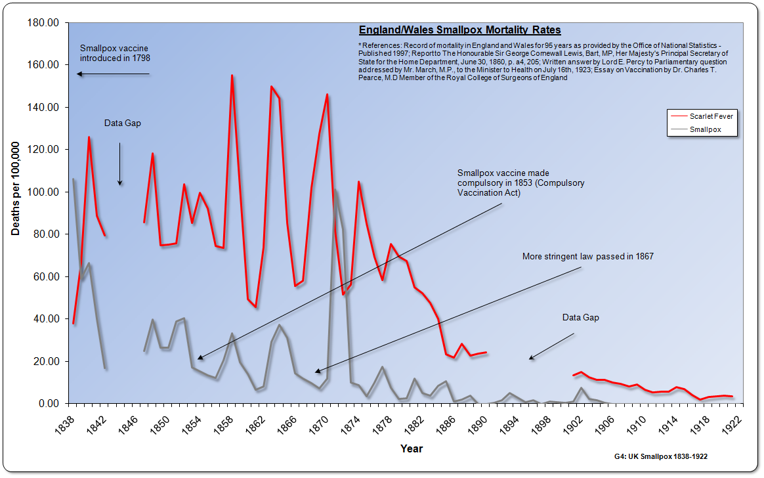

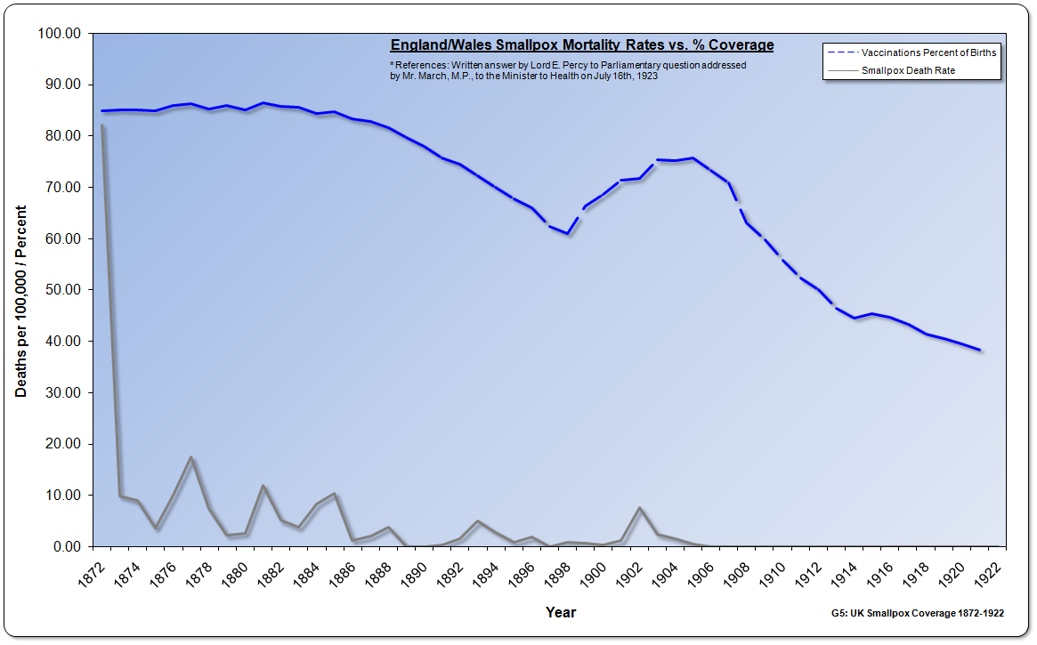

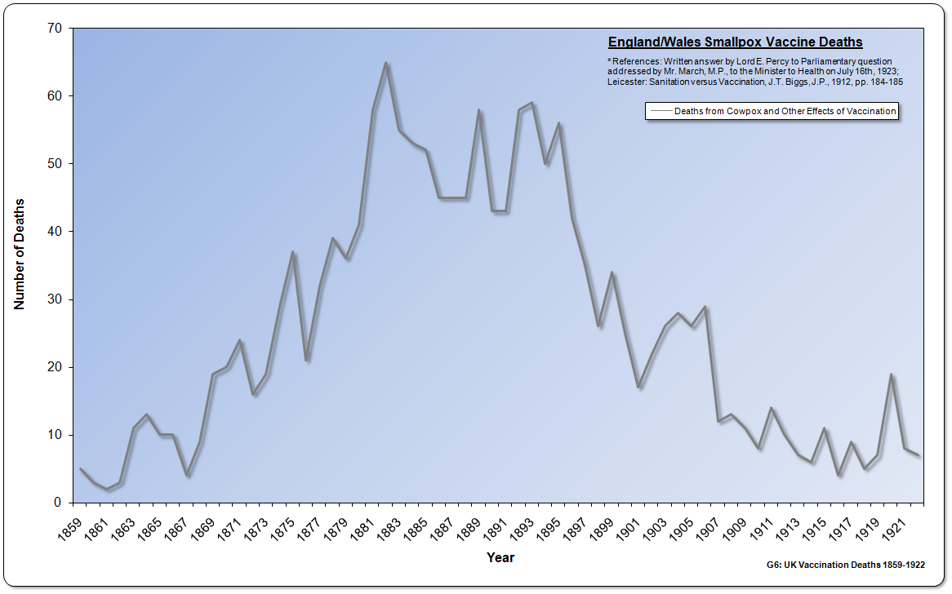

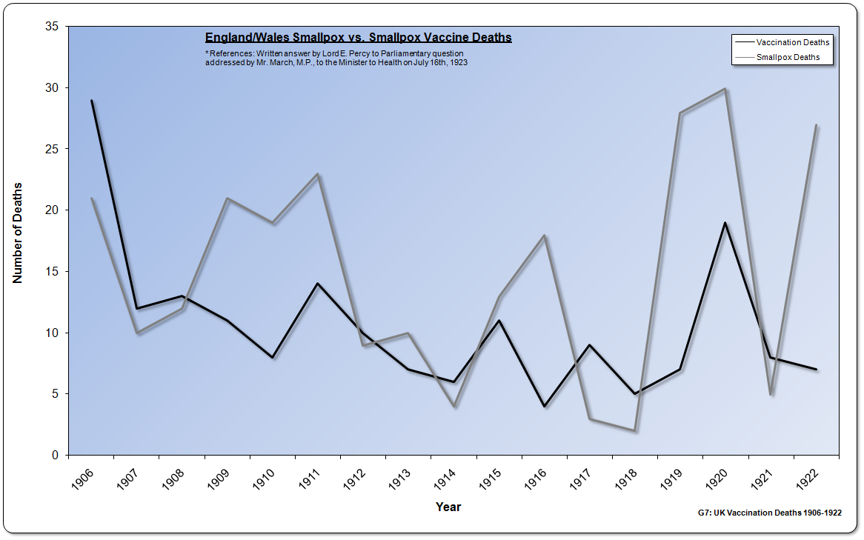

“George Banford had a child born in 1868. It was vaccinated and after the operation the child was covered with sores, and it was some considerable time before it was able to leave the house. Again Mr. Banford complied with the law in 1870. The child was vaccinated by Dr. Sloanne in the belief that by going to him they would get pure matter. In that case erysipelas set in, and the child was on a bed of sickness for some time. In the third case the child was born in 1872, and soon after vaccination erysipelas set in and it took such a bad course that at the expiration of 14 days the child died.”
Jaundice is the yellowish staining of the skin and the whites of the eye usually related to liver problems. It was found to be sometimes related to vaccination. One noted epidemic occurred among revaccinated adults at a large naval shipyard in Bremen Germany from October 1883 to April 1884.
“Owing to an alarm of smallpox, 1289 workmen were re-vaccinated between the 13th August and 1st September with the same humanized lymph preserved in glycerin; of these 191 had jaundice at various intervals down to the month of April following. Circumstantial evidence (agreement and difference) clearly traced the epidemic to the vaccination.”
Other diseases attributed to vaccination were also found to have occurred such as tuberculosis and syphilis. In 1863, Dr. Ricord spoke before the Academy at Paris.
“First I rejected the idea that syphilis could be transplanted by vaccination. But facts accumulated more and more, and now I must concede the possibility of the transfer of syphilis by means of the vaccine. I do this very reluctantly. At present I do not hesitate longer to acknowledge and proclaim the reality of the fact.”
In 1889, Dr. Charles Creighton published a book highly critical of Edward Jenner and vaccination. He observed that people who had been exposed to cowpox had also frequently submitted to inoculation. Jenner’s experiments were not controlled experiments in the modern sense. In the final analysis, Jenner came to a conclusion that he wanted to believe.
“The only real experiment in the paper on cowpox, as originally offered to the Royal Society, was the inoculation of James Phipps; the results of it, as we have seen, were recorded with a brevity which enabled Jenner to suppress the true and suggest the false. It is absurd to claim the dozen old cases of cowpoxed milkers, who were subsequently inoculated with smallpox, as experiments; there were many cowpoxed milkers... who submitted to inoculation along with others, whenever a general inoculation was afoot; and Jenner's cases were only a few, favourable to his contention... he himself stands for the man who ‘peremptorily decides on the truth or falsehood of a theory, on the supposed authority of a few solitary instances.’ ”
At the end of the 1800s smallpox changed its character. After the summer of 1897, the severe type of smallpox with its high death rate, with few exceptions, had entirely disappeared from the United States. Smallpox had turned from a disease that killed 1 in 5 of its victims to anywhere from 1 in 50 to as low as 1 in 380. This disease could still kill, but having become so much milder it was mistaken for various other diseases.
“During 1896 a very mild type of smallpox began to prevail in the South and later gradually spread over the country. The mortality was very low and it was usually at first mistaken for chicken pox or some new disease called ‘Cuban itch,’ ‘elephant itch,’ ‘Spanish measles,’ ‘Japanese measles,’ ‘bumps,’ ‘impetigo,’ ‘Porto Rico scratches,’ ‘Manila scab,’ ‘Porto Rico itch,’ ‘army itch,’ ‘African itch,’ ‘cedar itch,’ ‘Manila itch,’ ‘Bean itch,’ ‘Dhobie itch,’ ‘Filipino itch,’ ‘nigger itch,’ ‘Kangaroo itch,’ ‘Hungarian itch,’ ‘Italian itch,’ ‘bold hives,’ ‘eruptive grip,’ ‘beanpox,’ ‘waterpox,’ or ‘swinepox.”
The author of a 1913 article in The Journal of Infectious Diseasespresented a table showing that in 1895 and 1896 the smallpoxdeath rate was around 20%, as it had been historically. The table then showedthat after 1896 the death rate rapidly fell off starting with 6% in 1897to as low as 0.26% in 1908.
“On the whole the disease seems to have shown a tendency to diminish, somewhat in severity. This tendency is not marked and the somewhat lower case fatality noted in later years may be due to the better recognition of cases, now that the type has become more widely known. At first fatalities of 1 to 2 per cent and even more were commonly reported, while later fatalities have often been much less. Thus in North Carolina in 1910 there were 3,875 cases with 8 deaths, a fatality of 0.2 per cent, and in 1911 there were 3,294 cases in that state without a single death.”
Something had changed to make smallpox a much less dangerous disease.This new mild form of the disease had no secondary fever with patientshaving little discomfort if any. The eruptions as in classic smallpox, were often not more than a dozen and sometimes even less. The redness left by these eruptions often disappeared in three or four weeks, and usually left no permanent marks.
“Wherever this mild type of smallpox has appeared there has usually developed a controversy as to its nature. The public and the general practitioner consider smallpox a serious disease and they are loath to believe that an affliction so mild as is usually observed in this type can be real smallpox. The prodromal [early] symptoms are usually not severe, and when the eruption appears, they disappear entirely. After that, in the great majority of cases, the patient remains practically well.”
The article’s author hypothesized that this new milder form of smallpox could be a mutation of the original. Was that the case, or had something else changed to make this and all other infectious diseases less fatal?
“The evidence points to the existence in North America during the last 15 years of two distinct strains of smallpox, one the long recognized type of the textbooks, the other marked by decided mildness of symptoms. The latter is probably a mutation from the former. Both strains tend to breed true, and tho it is possible that a few outbreaks of the severe type may have developed from the mild type there is not conclusive evidence that they have been numerous, or extensive.”
As the mild form of smallpox replaced the classic type, smallpox could be difficult to tell apart from chickenpox, which was always considered a mild disease of childhood.
“…chickenpox, is a minor communicable disease of childhood, and is chiefly important because it frequently gives rise to difficulty in diagnosis in cases of mild smallpox. Smallpox and chickenpox are sometimes very difficult to differentiate clinically”
By the 1920s it was recognized that the new form of smallpox produced little in the way of symptoms, even though few had been vaccinated.
“Individual cases, or even epidemics, occur in which, although there has been no protection by vaccination, the course of the disease is extremely mild. The lesions are few in number or entirely absent, and the constitutional symptoms mild or insignificant”
As the mild form of smallpox replaced the classic and deadly variety, the rate of vaccination declined. This in turnincreased the anxiety of some in the medical community. The fear was that themilder type of smallpox could at some point revert back to its original and more deadly form.
“We must prepare for a pandemic of smallpox! … It has been two decades since epidemics of any proportions swept over the country and while the war [World War I] resulted in the vaccination of large numbers of young adults the very young are almost unvaccinated, while those of middle life and older have not been revaccinated for many years.”
By the 1920’s and 1930’s mild smallpox had almost completely replaced the severe form in the United States. There were exceptions however with outbreaks in seaports and near the Mexican border. Once the mild type of smallpox became prevalent, there was no evidence that it ever reverted to the older more virulent type.
“Although mild cases of smallpox were known before, they have come practically to replace the severe forms in many extensive areas, such as the whole United States, Brazil, large parts of Africa.”
“The mild form of smallpox commonly designated by its Portuguese name, alastrim, has prevailed over vast regions of the United States for over 30 years. It is estimated that the germ of this disease must have been transmitted from one human being to another more than 800 times and yet it is bred true. Throughout all these ‘generations’ the organism maintains its early characteristics… Most American health officers and epidemiologists who have experience with the two types of smallpox do not believe that as yet there has been any reversion of the mild strain to the old classic strain.”
Other diseases also changed from significant killers to being much milder. For example, in England from 1886 to 1890 smallpox killed 2,320 and during the same time period chickenpox killed 474. Although there was some dispute over the recording of deaths under smallpox or chickenpox, it is clear during these times that chickenpox did kill. By the early 1900s chickenpox, like smallpox, had become considered a minor disease that was usually not fatal.
The warning in 1921 of an impending smallpox epidemic never materialized despite declining vaccination rates.Smallpox had somehow changed,so it was hard to distinguish it from the mild childhood disease of chickenpox. Declining vaccination rates did not see a resurgence of the classic and deadly type of smallpox. Had the disease in fact changed or had something else occurred? Had the environment in which smallpox and other infectious diseases existed, changed?
This brief journey into the history of smallpox could only touch on information that would easily fill multiple books. Some of the key points uncovered were:
- Smallpox inoculation decreased the chance of death from smallpox for the individual, but was a vector for spreading smallpox.
- Vaccination was originally claimed to provide complete immunity for life from smallpox, but later downgraded to temporarily improved tolerance of smallpox.
- Vaccine failure was detected early on even when vaccinated by the inventor of vaccination, Edward Jenner. People still caught smallpox and even died.
- Vaccinated people also died of smallpox although it at times it was believed at less of a rate than when smallpox was acquired naturally.
- Vaccination was often of the “humanized” form with vaccinations being performed from arm to arm.
- Sometimes vaccination was simply the old form of inoculation and resulted in spreading smallpox.
- Deaths were sometimes recorded to favor vaccination.
- Despite high vaccination rates smallpox epidemics still occurred culminating in the great 1872 pandemic.
- After 1872 the death rate from smallpox decreased even while vaccination rates declined.
- People could and did die from vaccination.
- While the majority of medical men supported vaccination, there were many doctors and others that were strongly opposed.
- After 1906 about the same number of people died from vaccination as they did from smallpox.
- After 1896 the severity of smallpox changed from a big killer to a mild disease difficult to tell apart from chickenpox
- During the same time frame, like smallpox, chickenpox as well as other infectious diseases also became much less fatal
Smallpox was one of the most devastating historical diseases that caused many deaths and suffering, mostly before the 1900s. Smallpox inoculation was first tried to help stem the tide of this particular disease, which was later followed by vaccination. Ultimately, the decreasing deaths from smallpox occurred as vaccination rates dropped and smallpox became a much less deadly disease. These facts clearly showthat vaccination was not what caused the defeat of smallpox at the end of the 1800s into the 1900s.
However, the strong belief in vaccination caused the governments of the time to institute strict compulsory laws to ensure a high compliance rate in the population. After the 1872 pandemic,more people lost faith in vaccination, and they began believing in the ideas of sanitation, hygiene, better living, and isolation as the way to deal with smallpox. Their belief would clash with the medical profession and governmental laws, culminating in a large demonstration in 1885 against compulsory vaccination in the small manufacturing town of Leicester England.

William Douglass MA, A Summary, Historical and Political, of the First Planting, Progressive Improvements and Present State of the British Settlements of North-America, London, 1760, p. 407
Frederick F. Cartwright, Disease and History, Rupert-Hart-Davis, London, 1972, p. 124
Victor C. Vaughan MD, Epidemiology and Public Health, St. Louis, C.V. Mosby Company, 1922, p. 189
Frederick F. Cartwright, Disease and History, Rupert-Hart-Davis, London, 1972, pp. 125-126
William Douglass MA, A Summary, Historical and Political, of the First Planting, Progressive Improvements and Present State of the British Settlements of North-America, London, 1760, p. 398
“The Practice of Inoculation Truly Stated”, The Gentleman's Magazine and Historical Chronicle, Vol. 34, 1764, p. 333
Elizabeth A. Fenn, “The Great Smallpox Epidemic of 1775-82”, History Today, July 20, 2003, p. 12
Frederick F. Cartwright, Disease and History, Rupert-Hart-Davis, London, 1972, p. 127
Dr. Walter Hadwen, The Case Against Vaccination, Goddard’s Rooms, Gloucester, January 25, 1896, p. 12
Charles Creighton, Jenner and Vaccination, 1889, pp. 95-96
Frederick F. Cartwright, Disease and History, Rupert-Hart-Davis, London, 1972, p. 130
Alfred Russel Wallace, The Wonderful Century - Its Successes and Its Failures, 1989, p. 217
William Scott Tebb MD, A Century of Vaccination and What it Teaches, London: Swan Sonnenschein& Co., 1898, p. 126
“Vaccination by Act of Parliament”, Westminster Review, Vol. 131, 1889, p. 101
“Observations on Prevailing Diseases”, The London Medical Repository Monthly Journal and Review, Vol. VIII, July to December, 1817, p. 95
Henry Dewar, “Account of an Epidemic Small Pox, which occurred in Cupar in Fife in the Spring of 1817, and the Degree of Protecting Influence which Vaccination afforded; accompanied with Practical Inferences and Observation”, The London Medical Repository Monthly Journal and Review, Vol. VIII, July to December, 1817, p. 244
Henry Dewar, “Account of an Epidemic Small Pox, which occurred in Cupar in Fife in the Spring of 1817, and the Degree of Protecting Influence which Vaccination afforded; accompanied with Practical Inferences and Observation”, The London Medical Repository Monthly Journal and Review, Vol. VIII, July to December, 1817, p. 245
“Observations by Mr. Fosbroke”, The Lancet, Vol. II, 1829, p. 583
William Cobbett, Advice to Young Men and (Incidentally) to Young Women, 1829, London, pp. 224-225
“Observations by Mr. Fosbroke”, The Lancet, Vol. II, 1829, pp. 583-584
Dr. Delagrange of Paris, “On the Present State of Vaccination in France”, The Lancet, Vol. II, 1829, p. 582
Dr. Delagrange of Paris, “On the Present State of Vaccination in France”, The Lancet, Vol. II, 1829, p. 583
“Cowpox Origin of”, The Medico-chirurgical review and journal of practical medicine, Vol. 20, 1834, p. 504
Dr. Fiard, “Experiments upon the Communication and Origin of Vaccine Virus”, London medical and surgical journal, Vo. 4, 1834, p. 796
John Kilburn, “Epidemic Smallpox in 1833. Protective Power of Vaccination”, The Lancet, Vol. II, September 23, 1837 , p. 928
Ephraim Cutter MD, “Partial Report on the Production of Vaccine Virus in the United States”, Transactions of the American Medical Association: Volume XXIII, 1872, p. 200
The Encyclopaedia Britannica, Vol. 24, Philadelphia, 1890, p. 25
George Greogory, MD, “Brief Notices of the Variolous Epidemic of 1844”, Royal Medical and Chirurgical Society, Jan 28, 1845, p. 163
George Greogory, MD, “Brief Notices of the Variolous Epidemic of 1844”, Royal Medical and Chirurgical Society, Jan 28, 1845, p. 163
“Small Pox and Vaccination”, Hampshire Telegraph and Sussex Chronicle, Saturday March 2, 1850
The Morning Chronicle, Wednesday, April 12, 1854
Lloyd’s Weekly Newspaper, Sunday June 10, 1860
Glasgow Herald, December 14, 1870
The Morning Chronicle, Wednesday, October 23, 1861
The Ipswich Journal, November 7, 1876
Noel A. Humphries, "English Vaccination and Small-Pox Statistics; with special Reference to the Report of the Royal Commission, and to recent Small-Pox Epidemics", Journal of the Royal Statistical Society, Septemeber 1897, p. 545
Susan Wade Peabody, “Historical Study of Legislation Regarding Public Health in the State of New York and Massachusetts,” The Journal of Infectious Diseases, Supplement No. 4, February 1909, p. 50-51
“Memorial in Relation to the Small Pox”, City Document No. 30., City of Boston, 1856, p. 10
“Small-pox and Revaccination”, Boston Medical and Surgical Journal, Vol. CIV, No. 6, February 10, 1881, p. 137
Allan Nevins, A History of American Life Volume VIII – The Emergence of Modern America 1865-1878, The Macmillan Company, 1927, p. 321
G.W. Harman MD, “A Physician’s Argument Against the Efficacy of Virus Inoculation”, Medical Brief: A Monthly Journal of Scientific Medicine and Surgery: Vol. 28, No. 1, 1900, p. 84
Alexander Wilder, MD, “The Fallacy of Vaccination”, The Metaphysical Magazine, Vol. III, No. 2, May 1898, p. 88
Charles Ruata, M. D., Professor of Hygiene and of MateriaMedica in the University of Perugia, “Vaccination in Italy”, The New York Medical Journal, July 22 1899, pp. 188-189
Encyclopedia Britannica, 1888
Thomas Neville Bonner, Medicine in Chicago 1850-1950 A Chapter in the Social and Scientific Development of a City, The American History Research Center, Madison, Wisconsin, 1957, pp. 181-182
Thomas Neville Bonner, Medicine in Chicago 1850-1950 A Chapter in the Social and Scientific Development of a City, The American History Research Center, Madison, Wisconsin, 1957, p. 182
The Encyclopaedia Britannica, Vol. 24, Philadelphia, 1890, p. 29
Michael Willrich, POX. An American History, Penguin Press, New York, 2011, p. 4
J.W. Hodge, MD, “State-Inflicted Disease in our Public Schools”, Medical Century, October 1908, Vol. XVI, No. 10, pp. 308-314
Dr. Olesen, “Vaccination in the Phillippine Islands”, Medical Sentinel, April 1911, Vol. 19, No. 4, p. 255
The Encyclopaedia Britannica, Vol. 24, Philadelphia, 1890, p. 26
Stanley Williamson, “Anti-Vaccination Leagues”, Archives of Disease in Childhood, 1984, Vol. 59, p. 1195
The Encyclopaedia Britannica, Vol. 24, Philadelphia, 1890, p. 26
“Vaccination”, New York Times, September 26, 1869
Charles Creighton, Jenner and Vaccination, 1889, p. 59
Charles V. Chapin, “Variation in Type of Infectious Disease as Shown by the History of Smallpox in the United States”, The Journal of Infectious Diseases, Vol. 13, No. 2, September 1913, p. 173
Charles V. Chapin, “Variation in Type of Infectious Disease as Shown by the History of Smallpox in the United States”, The Journal of Infectious Diseases, Vol. 13, No. 2, September 1913, p. 178
Charles V. Chapin, “Variation in Type of Infectious Disease as Shown by the History of Smallpox in the United States”, The Journal of Infectious Diseases, Vol. 13, No. 2, September 1913, p. 179
Charles V. Chapin, “Variation in Type of Infectious Disease as Shown by the History of Smallpox in the United States”, The Journal of Infectious Diseases, Vol. 13, No. 2, September 1913, p. 196
John Gerald Fitzgerald, Peter Gillespie, Harry Mill Lancaster, An introduction to the practice of preventive medicine, C.V. Mosby Company, 1922, p. 197
John Price Crozer Griffith, The diseases of infants and children, Volume 1, W.B. Saunders Company, 1921, p. 370
G. Koehler, Pharmacology and therapeutics, preventive medicine, The Year Book Publishers, 1921, p. 322
George Dock, MD, “Smallpox and Vaccination”, Journal of the Missouri State Medical Association, Vol. 19, April 1922, p. 168
Charles V. Chapin and Joseph Smith, “Permanency of the Mild Type of Smallpox”, Journal of Preventive Medicine, 1932

